Worksheet 1.2
Student Name: Ayush Yadav UID: 25IMC13004
Branch: MCA (AI & ML) Section/Group: MAM-1 (A)
Semester: II Date of Performance: 19/01/26
Subject Name: Advance Internet Programming Subject Code: 25CAP-656

1. Aim/Overview of the practical:

Create a serlvet that describes how to use the HttpSession object to find out the creation time and the last-accessed time for a sess ion.

2. Coding:
import java.io.IOException;
import java.io.PrintWriter;
import jakarta.servlet.ServletException;
import jakarta.servlet.annotation.WebServlet;
import jakarta.servlet.http.HttpServlet;
import jakarta.servlet.http.HttpServletRequest;
import jakarta.servlet.http.HttpServletResponse;
import jakarta.servlet.http.HttpSession;

@WebServlet(urlPatterns = {"/ServSessTime"})
public class ServSessTime extends HttpServlet {
protected void processRequest(HttpServletRequest request, HttpServletResponse response)
throws ServletException, IOException {
response.setContentType("text/html");
PrintWriter out = response.getWriter();
HttpSession session = request.getSession(true) ;
long create_time = session.getCreationTime();
long access_time = session.getLastAccessedTime();

if (session.isNew()){
out.println("<h2>New User</h2>");
}
else {
out.println("<h2>Old zUser</h2>");
}
java.util.Date date = new java.util.Date(create_time);
java.util.Date time = new java.util.Date(access_time);
out.println("<h3>Session creation time: " + date + "</h3>");
out.println("<h3>Last Accessed time:" +time+ "</h3>");
}

@Override
protected void doGet(HttpServletRequest request, HttpServletResponse response)
throws ServletException, IOException {
processRequest(request, response);
}

@Override
protected void doPost(HttpServletRequest request, HttpServletResponse response)
throws ServletException, IOException {
processRequest(request, response);
}
}

OUTPUT:
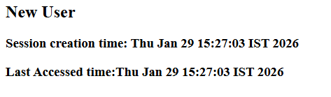

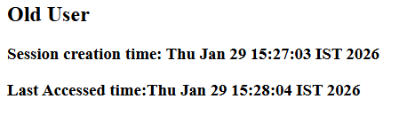

3. Learning outcomes:
- Explore how to create and manage HttpSession objects in servlets.
- Identify whether a session is new or existing using session.isNew().
- Retrieve session creation and last accessed times with getCreationTime() and getLastAccessedTime().
- Convert session timestamps into human-readable Date objects.

